CISP 41 Programming in C#

Project Evaluation Sheet
Student Name: ___________ Bryant Tunbutr ____________________ Project Number: _______4________
Project Name: _______BtunbutrProject4_____ Visual Studio Version: ___2008________
Date Due: ________11/22/12_____________ Date Turned In: _____11/22/12_____
Above to be completed by student
Points ( ____ Possible)
Correctness/Efficiency:

Output is accurate ____________

Meets all requirements ____________

Provide appropriate user interface ____________

Logic is efficient ____________

Documentation/Coding Style:
Project can be open from the submitted zip file ____________

Folder is present and contains all necessary project files (no extra files) ____________

Use required coding template ____________

Use proper naming and spacing ____________

Submit all requested information ____________

Test Cases:

List all required test cases ____________

Provide output forms for important test cases ____________

Other issues: ____________

Extra Credit: ____________

Timeliness: ____________

Project Score:

CISP 41 Programming in C#

Project specification

This software is intended to give the spark plug number that is equivalent to other brands.

It is designed to be run in Visual Studio 2008 using the C# coding.

It uses user input including the selected brand and number of the part.

It displays CCC brand number.

Used in the project are arrays, 2-dimensional arrays, methods, list boxes.

CISP 41 Programming in C#

Project status

The project is not complete.

I tried for many hours to get the text file into an array of structure.

I was successful in loading the file into string arrays using this code

//Load text file
TextReader tr = new StreamReader("C:\\Users\\bryantt\\Desktop\\project 4 3 test\\WindowsFormsApplication1\\bin\\Debug\\test.txt");

//lines loaded
int NumberOfLines = 5;

//array for each line
string[] ListLines = new string[NumberOfLines];

//Read the number of lines and put them in the array
for (int i = 1; i < NumberOfLines; i++)
{
ListLines[i] = tr.ReadLine();
}

//Make array for each line
string[] ccc = ListLines[1].Split(new Char[] { ',' });
string[] brandsA = ListLines[2].Split(new Char[] { ',' });
string[] brandsB = ListLines[3].Split(new Char[] { ',' });
string[] brandsC = ListLines[4].Split(new Char[] { ',' });

// close the stream
tr.Close();

However I was never able to get these string arrays to convert into a 2-dimensional array structure.

I tried parsing methods, I tried integer and character and string conversion without success. I also tried making using loops to create 2-dimensional arrays without success.

I also tried just using these arrays but was unable to do so successfully

I do know that these arrays worked in exporting the data from the text file because when used code like the following, I got successful results

textBox1.Text = brandsB[3].ToString();

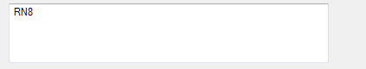

I feel that the project is 95% complete, I am just missing one step of converting these string arrays into the 2-dimensional arrays that I used in the finalized project

CISP 41 Programming in C#

Sketch of user interface

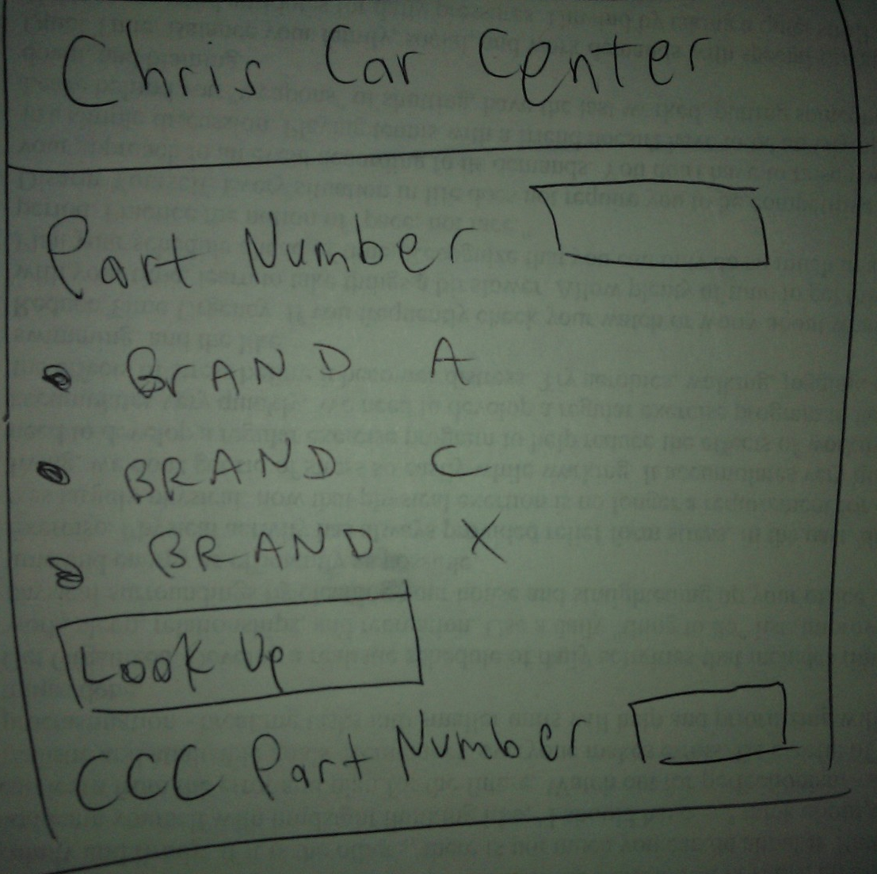

CISP 41 Programming in C#

Objects and Properties Plan for __ BTunbutrProject 4_________Form
Object | Property | Setting
Look Up Button | Name Text | Method
Look Up | Name Text | Button Click
If loop | Text | Method
label | Name Text | Part Number
Combo text box | Text | Drop down
BTunbutrProject4 | Name Text | Form
brandsString | Text | array
cccString | Text | array

CISP 41 Programming in C#

Event Plan for ___ BTunbutrProject 4________Form
Object | Event | Action - Pseudocode
Look Up Button | Click | Call Look Up Button_Click.  Display the part number.  Run methods with arrays
Part number | Click | Use in method to match
List box | Click | Select array
ccc number | Click | Display method results

CISP 41 Programming in C#

Test cases and captured screens

Test case #1
Nothing selected

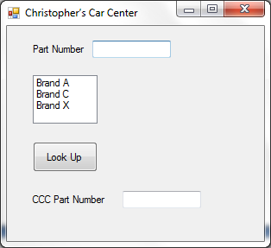

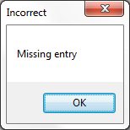

Test case #2a
Only a part number is entered

Test case #2b
Only a brand is selected

Test case #3

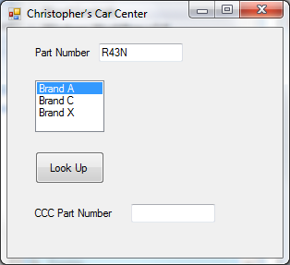

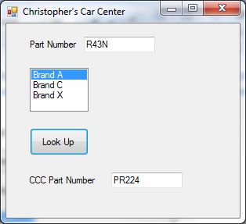

Test case #4

Part #14K44 with each of the brands selected

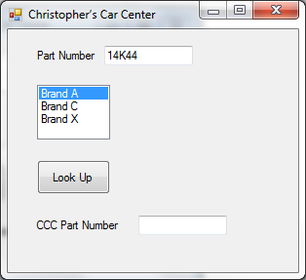

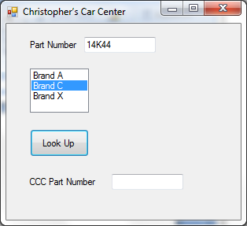

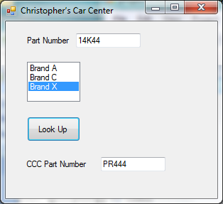
Test case #5

A non existing part number is entered

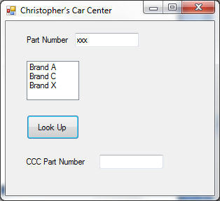

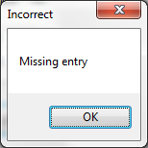

Test case #6

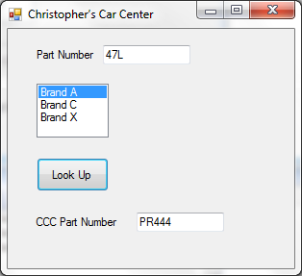

Test case #7
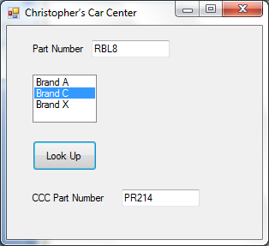

Test case #8
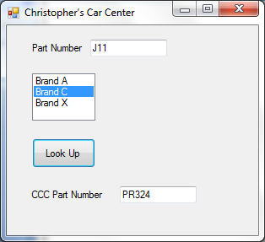

CISP 41 Programming in C#
Source code

/*
* Project: BtunbutrProject4
* Programmer: Bryant Tunbutr
* Date: Nov 22 2012
* Description: Uses array of structures to match part number with brand number
* I certify that the code below is my own work.
*/

using System;
using System.Collections.Generic;
using System.ComponentModel;
using System.Data;
using System.Drawing;
using System.Linq;
using System.Text;
using System.Windows.Forms;
using System.IO;

namespace WindowsFormsApplication1
{
public partial class Form1 : Form
{
//Create arrays, 2 dimensional for brands
string[,] brandsString = new string[9, 3];
string[] cccString = new string[9];

public Form1()
{
InitializeComponent();
}

private void lookUpButton_Click(object sender, EventArgs e)
{
//Organize by having each brand have same second integer,
//i.e. Brand A has second integer of 0

//Brand A
brandsString[0, 0] = "MR43T";
brandsString[1, 0] = "R43";
brandsString[2, 0] = "R43N";
brandsString[3, 0] = "R46N";
brandsString[4, 0] = "R46TS";
brandsString[5, 0] = "R46TX";
brandsString[6, 0] = "S46";
brandsString[7, 0] = "SR46E";
brandsString[8, 0] = "47L";

//Brand C
brandsString[0, 1] = "RBL8";
brandsString[1, 1] = "RJ6";
brandsString[2, 1] = "RN4";
brandsString[3, 1] = "RN8";
brandsString[4, 1] = "RBL17Y";
brandsString[5, 1] = "RBL12-6";
brandsString[6, 1] = "J11";
brandsString[7, 1] = "XEJ8";
brandsString[8, 1] = "H12";

//Brand X
brandsString[0, 2] = "14K22";
brandsString[1, 2] = "14K24";
brandsString[2, 2] = "14K30";
brandsString[3, 2] = "14K32";
brandsString[4, 2] = "14K33";
brandsString[5, 2] = "14K35";
brandsString[6, 2] = "14K38";
brandsString[7, 2] = "14K40";
brandsString[8, 2] = "14K44";

//CCC NUMBER
cccString[0] = "PR214";
cccString[1] = "PR223";
cccString[2] = "PR224";
cccString[3] = "PR246";
cccString[4] = "PR247";
cccString[5] = "PR248";
cccString[6] = "PR324";
cccString[7] = "PR326";
cccString[8] = "PR444";

int brandInteger = brandListBox.SelectedIndex;
int lengthInteger = 9;

//make sure user has selected and entered data
if (partNumberTextBox.Text != "" && brandInteger != -1)

for (int indexInteger = 0; indexInteger < lengthInteger; indexInteger++)
{
//match part number with brand number.
if (partNumberTextBox.Text == brandsString[indexInteger, brandInteger])
{
//display result.
cccPartNumberTextBox.Text = cccString[indexInteger];
}
}

//check for exeption.
else
{
MessageBox.Show("Missing entry", "Incorrect");
}
}

}
}

